|  |
| --- |
| Department of Software Engineering  Mehran University of Engineering and Technology, Jamshoro |

|  |  |  |  |
| --- | --- | --- | --- |
| Course: SWE324 - Data Warehousing and Data Mining | | | |
| Instructor | Rabeea Jaffari | **Practical/Lab No.** | 04 |
| Date |  | **CLOs** | CLO-4: P3 & P4 |
| Signature |  | **Assessment Score** | 1 Mark |

|  |  |
| --- | --- |
| Topic | To familiar with OLTP system reporting |
| Objectives | * To learn report generation in OLTP systems |

|  |
| --- |
| Lab Discussion: Theoretical concepts and Procedural steps |

LAB NO 4

|  |
| --- |
| Lab Tasks |
| Submission Date: 23-04-19 |

Generate an OLTP system report which displays the following results:

1. **Total sales in a month** (Use only order table).
2. **Profit/loss in a month** (Use product (to account for purchasing costs), expenditure as well as order tables).
3. **Highest selling product of the month**(By highest sold quantity)
4. **Lowest selling product of the month**(By lowest sold quantity

**Solution:**

**Tables in sqlyog:**

**Product table:**

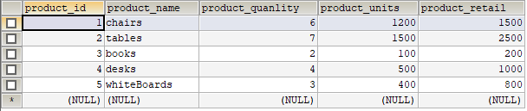

**Order_details table:**

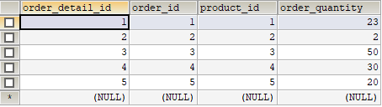

**Order table:**

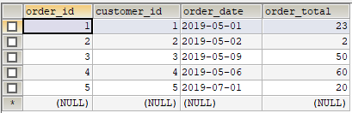

**Expenditure table:**

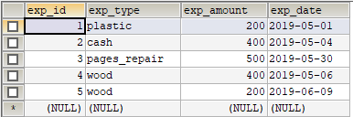

**Customer table**

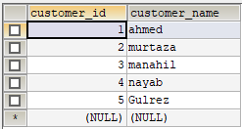

**Executed Queries for all above tasks:**

1)SELECT SUM(exp_amount) FROM expenditure WHERE `exp_date` LIKE '2019-05-01' AND '2019-05-30';



2)SELECT SUM(order_total) AS total_sale FROM `order` WHERE `order_date` LIKE '2019-05%';



3)SELECT (SUM(product.product_retail)-(SUM(product.product_units)+SUM(expenditure.exp_amount))) AS Profit_Loss FROM

product product INNER JOIN expenditure expenditure ON product.product_id= expenditure.exp_id WHERE expenditure.exp_date IN

(SELECT order.order_date FROM `order` `order` HAVING order.order_date BETWEEN '2019-05-01' AND '2019-05-30');



4)SELECT product.product_name FROM product product INNER JOIN order_details order_details ON

product.product_id=(SELECT order_details.product_id WHERE order_details.order_quantity=

(SELECT MAX(order_details.order_quantity) FROM order_details order_details));



5)SELECT product.product_name FROM product product INNER JOIN order_details order_details ON

product.product_id=(SELECT order_details.product_id WHERE order_details.order_quantity=

(SELECT MIN(order_details.order_quantity) FROM order_details order_details))

INSERT INTO result(`type`) VALUES ('highest_sale_product'),('lowest_sale_product');



**Report of all above task:**

DELIMITER $$

CREATE

/*[DEFINER = { user | CURRENT_USER }]*/

PROCEDURE `reportdb`.`report`()

/*LANGUAGE SQL

| [NOT] DETERMINISTIC

| { CONTAINS SQL | NO SQL | READS SQL DATA | MODIFIES SQL DATA }

| SQL SECURITY { DEFINER | INVOKER }

| COMMENT 'string'*/

BEGIN

SELECT @total_expend:=SUM(exp_amount) AS total_expend FROM expenditure WHERE `exp_date` LIKE '2019-05-01' AND '2019-05-30';

INSERT INTO result(total_expend) VALUES (@total_expend);

SELECT @total_sale:=SUM(order_total) AS total_sale FROM `order` WHERE `order_date` LIKE '2019-05%';

INSERT INTO result(total_sale) VALUES (@total_sale);

SELECT @profit_loss:=(SUM(product.product_retail)-(SUM(product.product_units)+SUM(expenditure.exp_amount))) AS Profit_Loss FROM

product product INNER JOIN expenditure expenditure ON product.product_id= expenditure.exp_id WHERE expenditure.exp_date IN

(SELECT order.order_date FROM `order` `order` HAVING order.order_date BETWEEN '2019-05-01' AND '2019-05-30');

INSERT INTO result(profit_loss) VALUES (@profit_loss);

SELECT * FROM result;

SELECT @low_sale_product:=product.product_name FROM product product INNER JOIN order_details order_details ON

product.product_id=(SELECT order_details.product_id WHERE order_details.order_quantity=(SELECT MIN(order_details.order_quantity)

FROM order_details order_details));

INSERT INTO result(lowest_sale_product) VALUES (@low_sale_product);

SELECT * FROM result;

SELECT @high_sale_product:=product.product_name FROM product product INNER JOIN order_details order_details ON

product.product_id=(SELECT order_details.product_id WHERE order_details.order_quantity=

(SELECT MAX(order_details.order_quantity) FROM order_details order_details));

INSERT INTO result(high_sale_product) VALUES (@high_sale_product);

SELECT * FROM result;

END$$

DELIMITER ;

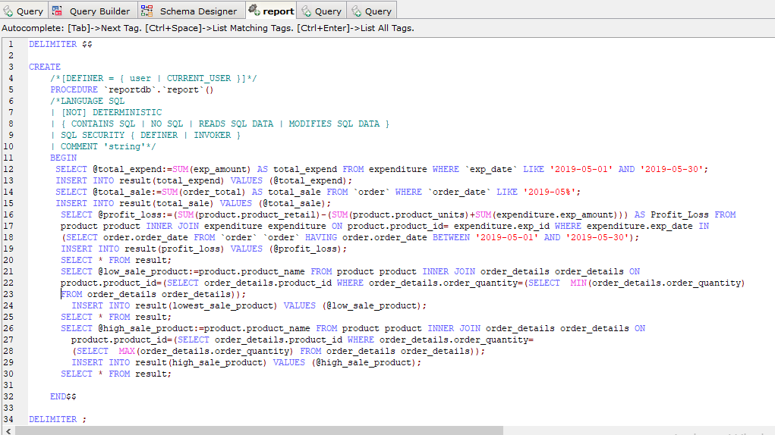

**Result:**

